Inventory System

1. Open a FPS template
2. Create a folder to keep all inventory related stuffs
3. Create a widget and name it InventoryUI
4. Add the following elements

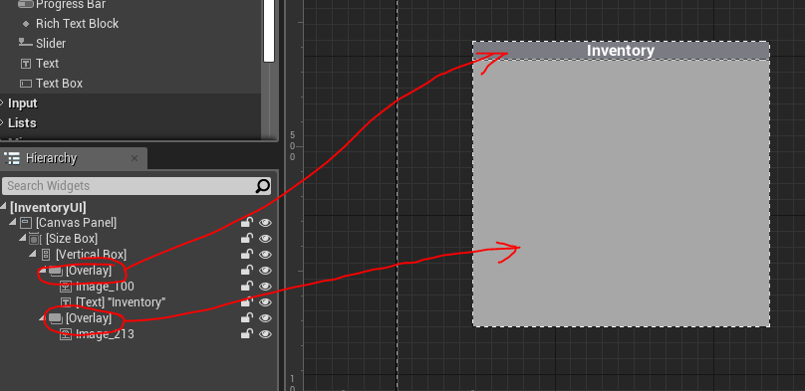

1. In the event graph create a new function called show and add the following BP to the function

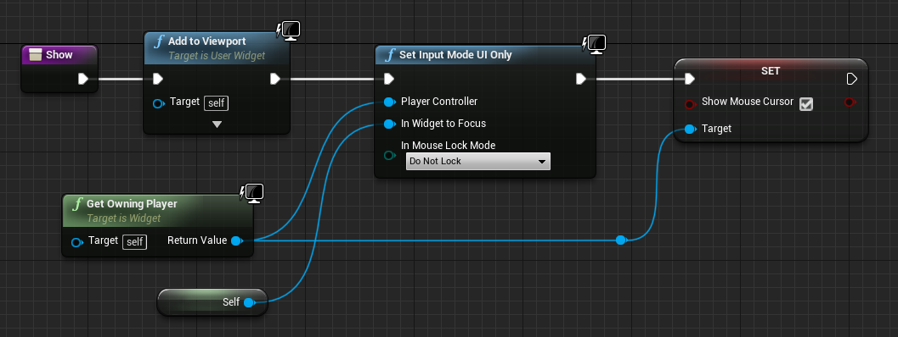

1. Now go to FirstPersonCharacter and delete all the BP connected to the EventBeginPlay (it is required only if we us VR)
2. Add the following BP to begin play and add a key input “I” and add BP as in image below

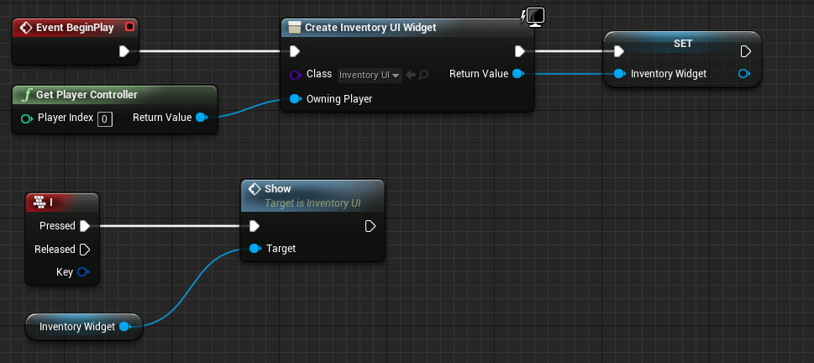

1. Now when we play and press the I key we should get the window
2. To close the Inventory window add a function and name it Hide
3. Add the following BP

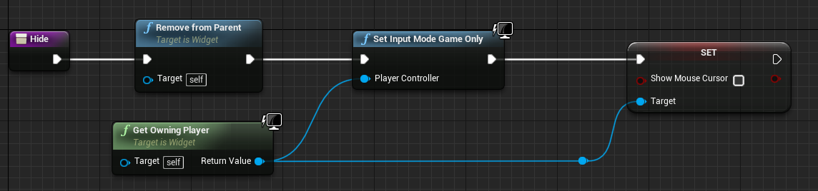

1. Add a button next to the text “inventory” in the designer tab

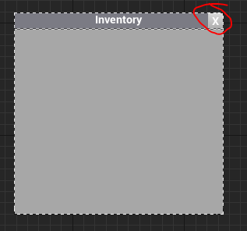

1. On the button click call the function Hide as below

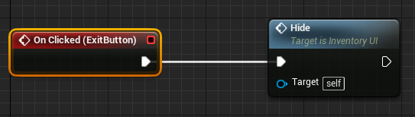

1. Now in game we should get the window on pressing “I” key and we should be able to close the window and get the control back to game.
2. Now we need to add pickups.
3. Create an actor class BP, name it “PickUp” and add a Sphere collision components to it

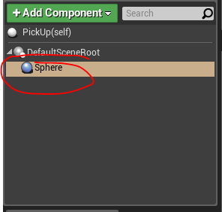

1. Now we will create a child blueprint class of the pickup
2. So Right click on the PickUp actor class and select child BP class

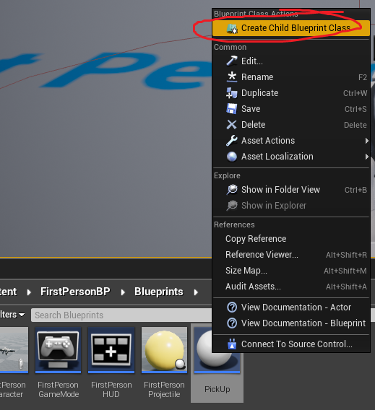

1. This will create a BP class of child PickUp Actor. Name it Apple pickup
2. Open it select the SphereCollision and add a static mesh.

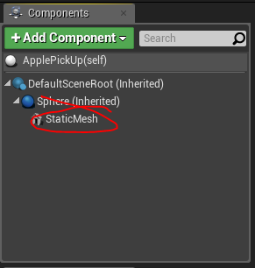

1. Select the static mesh and add a mesh from the details panel.
2. Adjust the size by playing in the level.
3. Now we need to pickup the apple
4. First create a function in PickUp called Hide. So when we press X in the game we call this function and hide the actor.

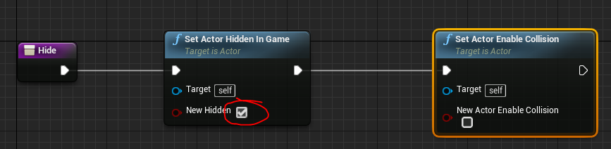

1. Now go to the Character and add the following BP

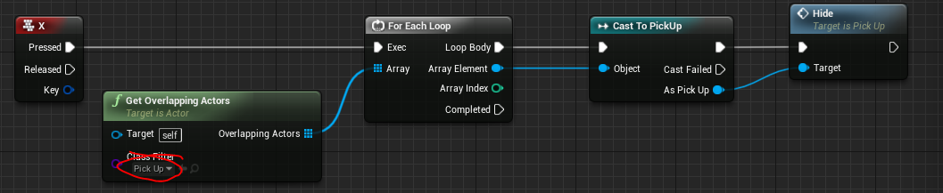

1. Now we should be able to hide the actors.
2. To make the pickups appear in the widget we need to add more components to the widget.
3. So open the widget and add a WrapBox to the second overlay

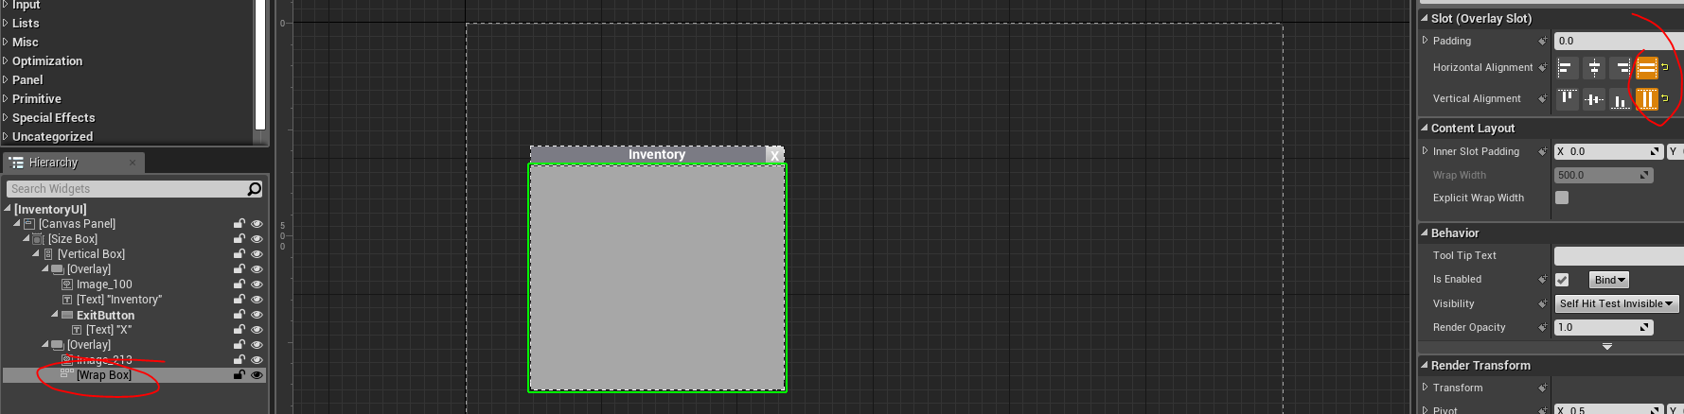

1. Add an image to the WrapBox
2. Right click on the image and go to WrapWith/Sizebox

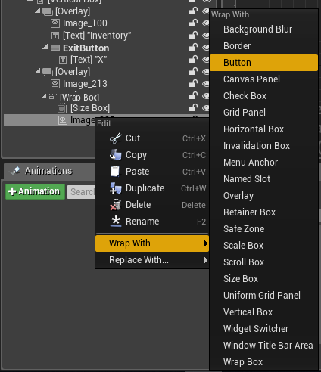

1. Select the size box and check the width override and height override and add 100 to both

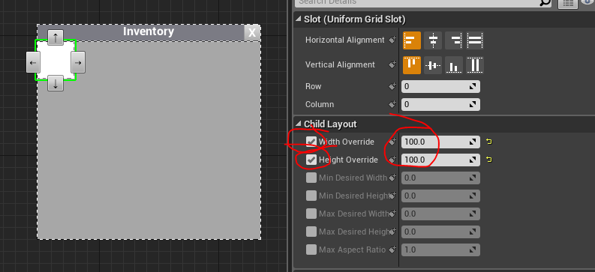

1. Add and apple image to Unreal Engine.
2. Select the image in the Widget and select the apple image in appearance

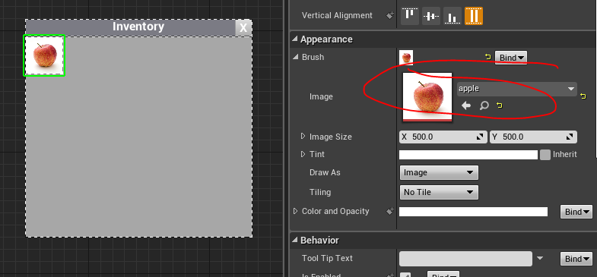

1. We need to make it clickable
2. So right click on the image and go to WrapWith/Button

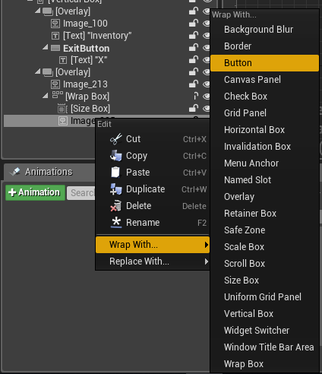

1. Final setup will look like this

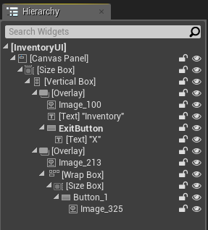

1. We should be repeatedly be able to create Size Box, Button and Image in the grid panel. So we will cut it and make it in a new widget.

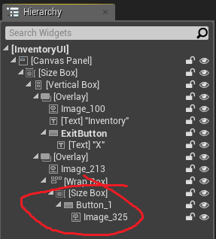

1. So create a new widget and name it InventoryItem
2. Open it and delete the canvas panle in the heirarchy window.
3. Go to the InventoryUI and cut the sizeBox (it will take all elements below the heirarchy) and paste in the new widget.

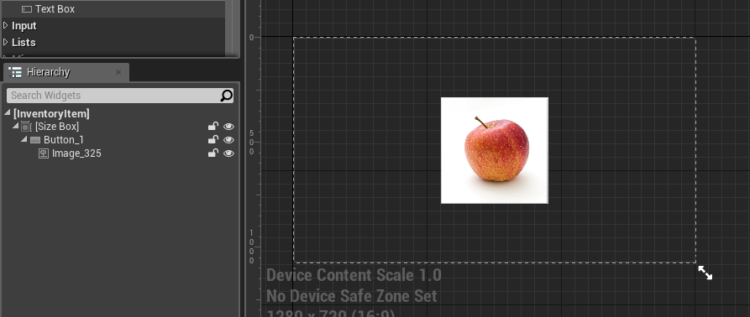

1. Go to InventoryUI and add new function called AddInventoryItem.
2. Add an input to the function of type PickUp and name the input, PickUp
3. Select the WrapBox and check ‘Is Variable’ in the details panel (top right)
4. You can also remane to WrapBoxInventory
5. Add the following BP

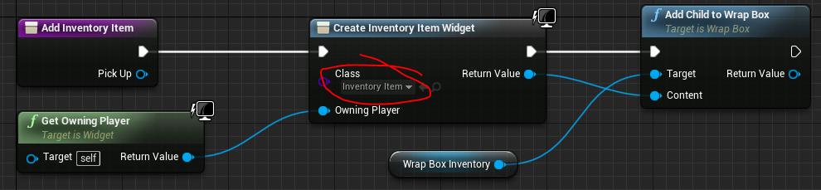

1. We can test it by adding this function to EventConstruct several times. Check if the inventory is displayed the number of times added in the event construct when we press I in game.
2. Go to Character BP and Modify the BP as follows.

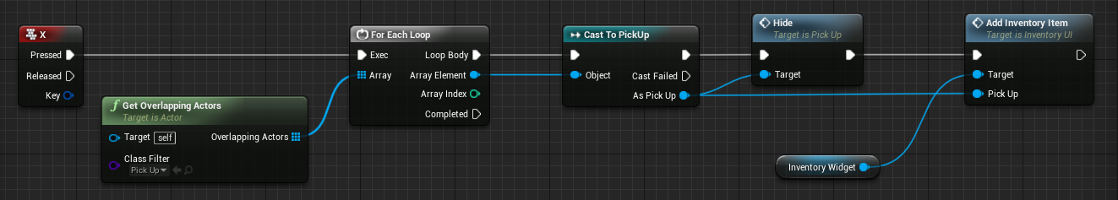

1. Now we need to drop the item when we click the inventory in the widget.
2. So go to the inventoryItem add a variable of type PickUp and name it PickUp.
3. Go to the InventoryUI widget and add the following to the AddInventoryitem function.



1. Now go to the InventoryItem widget and select the button and create an on clicked event.
2. Add the following BP

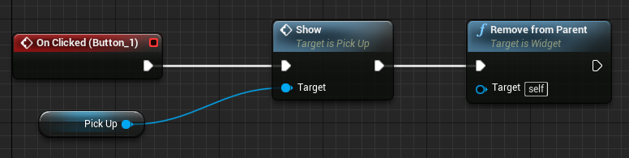

1. Inventory should be ready for pick up and drop in the game.
2. Now we need gun
3. Import gun mesh and Image.
4. Rename InventoryItem as InventoryItemApple
5. Make a duplicate and rename it InventoryItemGun
6. Edit the add inventory item function as follows

